**Lesson 4 Demo 15**

**Building Self-Healing Pods with Restart Policies**



Steps to be followed:

1. Create a Self-Healing Pod

**Step 1: Creating a self-healing pod**

* 1. Open singlepod.yaml using the following command:

***cd deployments***

***vi singlepod.yaml***

* 1. Edit singlepod.yaml by adding the **replicas** flag in **spec** section:

***spec:***

***containers:***

***- name: nginx***

***image: nginx***

***replicas: 6***

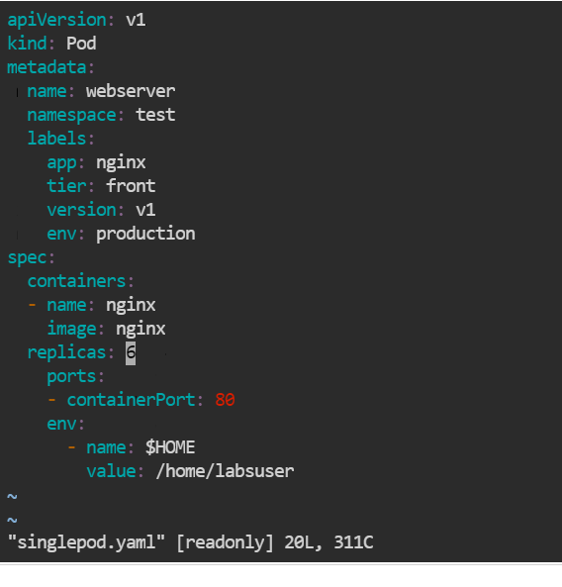

* 1. Type the following command to apply the changes:

***sudo kubectl apply -f singlepod.yaml -n test***

* 1. Check the newly created pod:

***sudo kubectl get pod -A -n test***

| **Note**: Restart policy is defined as restart Policy in the ***spec*** section. Restart Policy is always set default. So, it is not explicitly mentioned in the file. |
| --- |